**e. AWS Trusted Advisor**

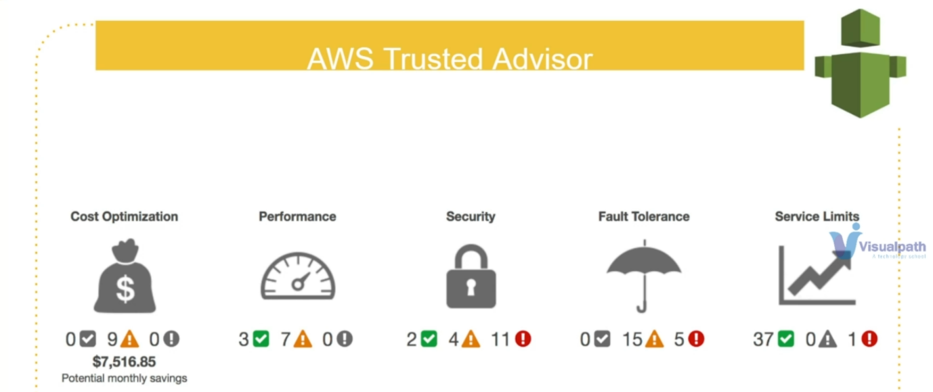

--- AWS trusted adviser, as the name says, it's an adviser, you really don't need to do much.

--- **Cost optimization** - You just need to use the service. It will give you advice on cost optimization. You know, maybe you have some EC2 instance, that is not used for a very, very long time or you have some EBS volume that are unused. So, it will alert you, hey, you have resources, you're not using it now.

--- **performance** - You have too many users coming in and accessing a particular service. it's not optimized and the most requests are slowing down, failing. So, it will give recommendation.

--- **security** – this service will tell me, hey, you know, there is a port. This is crazily open and you should better take a look at that or your access keys are exposed to the public. It's in the GitHub public repository. So, it will tell you that. it will scan for the public repositories also and if there is any access keys and, it will alert you.

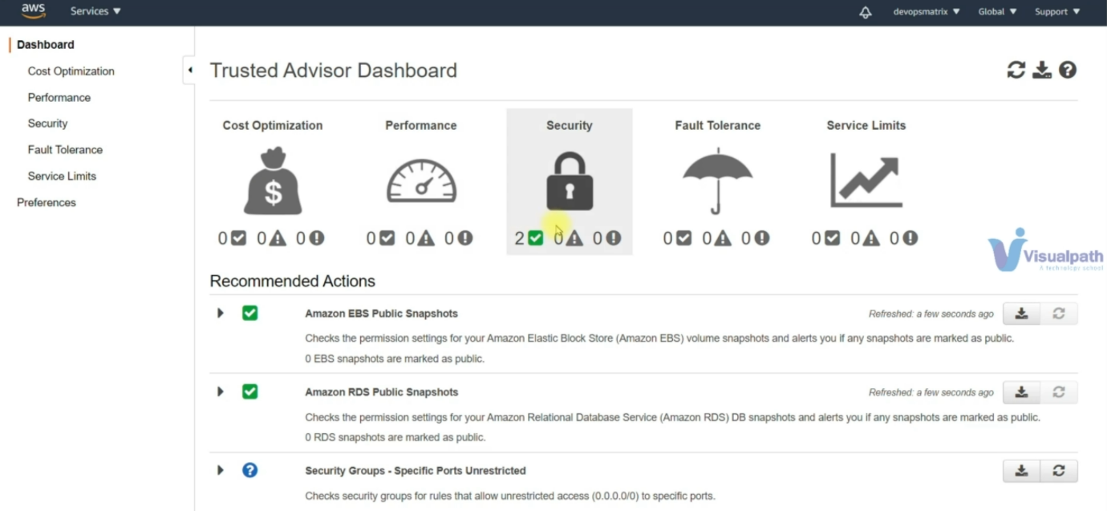

--- if you have any problems then it will show them here.